10 Oct 23 - Activity: Matching Boundary Conditions and Plotting the Potential

Azimuthally Symmetric Solutions
As we saw, azimuthally symmetric solutions, the electric potential is independent of $ϕ$ and the solutions are of the form:
$$V(r,θ)=\sum_{n=0}^{∞}{\sum_{l=0}^{∞}{\left(A_{nl}r^{n}+\frac{B_{nl}}{r^{n+1}}\right)}}P_{l}(cosθ)$$
where $P_{l}(cosθ)$ are the Legendre polynomials. The coefficients $A_{nl}$ and $B_{nl}$ are determined by the boundary conditions. We will practice solving for these coefficients in this activity.
✅ Do this

Sphere of constant surface potential
Consider a sphere of with a radius $a$. If the potential on the surface is $V_{0}$, what is the potential inside and outside the sphere?
- Consider the radial solutions (what doesn’t blow up?)
- Consider the polar angle solutions, what has to be true? What does that say about terms with $l>0$?
- Write down the solution inside and outside the sphere.
- Make a heat map plot (in $x$ and $y$) of the potential inside and outside the sphere. You can set $a=1$ and $V_{0}=1$ if that helps.
## your code here
✅ Do this

Sphere of variable potential
Consider a sphere of with a radius $a$. If the potential on the surface is $V(θ)$, what is the potential inside and outside the sphere?
- Consider the radial solutions (what doesn’t blow up?)
- Consider the polar angle solutions, what has to be true? Can you say anything about them?
- What if $V(θ)=V_{0}cos(θ)$? What is the potential inside and outside the sphere?

A thick spherical shell
Suppose you have a spherical shell of inner radius $a$ and outer radius $b$, and you know the electric potential on the inner ($V(a,θ)=V_{a}(θ)$) and outer ($V(b,θ)=V_{b}(θ)$) surfaces. You want to find the electric potential $V(r,θ)$ inside the hole ($r<a$) and outside the shell ($r>b$).
Let’s allow:
$$V_{a}(θ)=V_{a0}+V_{a1}cos(θ)$$
$$V_{b}(θ)=V_{b0}+V_{b1}cos(θ)$$
- What is the general solution? (all three regions)
- What are the boundary conditions for $r$?
- What terms are left in the general solutions?
- Find the unique solution for $V(r,θ)$ inside the hole ($r<a$) and outside the shell ($r>b$).
What do you do in the case of $V_{a}(θ)=f(θ)$ and $V_{b}(θ)=g(θ)$ - generic functions?

Example of Polarization
✅ Do this
Put a metal sphere of radius $a$ in a uniform electric field $\vec{E}=E_{0}\hat{z}$.
[Image not embedded: remote images are not included in PDF export. Check the original file for the image.] 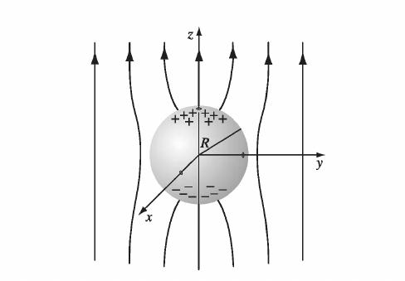
What is the potential inside and outside the sphere?
- Draw the picture and write down the boundary conditions. What is the potential everywhere on a metal?
- What general solution do you need to use? How do you know?
- What are the boundary conditions for the radial solutions? The polar angle solutions?
- Match your boundary conditions to your general solution. What is the potential inside and outside the sphere?
- Make a heat map plot (in $x$ and $y$) of the potential inside and outside the sphere. You can set $a=1$ and $E_{0}=1$ if that helps.
- (challenge) Find the polarization charge density on the surface of the sphere. What is the total charge on the sphere?
## your code here

