6 Oct 23 - Notes: Fast Fourier Transform
It might not have been obvious to you, but our work so far has expected that our $V(t)$ be a continuous function of time, and that we can sample it any time we want. In reality, you are limited to the response of your equipment, which leads to a phenomenon knows as the Nyquist-Shannon sampling theorem. This theorem states that if you want to study a signal with a frequency $f$, you need to sample it at least $2f$ times per second. This is known as the Nyquist frequency. If you don’t sample at least this often, you will get aliasing, which is when a signal at a higher frequency is indistinguishable from a signal at a lower frequency. As you can tell, there’s a lot of issues with sampling when it comes to studying signals.

The Fast Fourier Transform
This video from Veritasium really explains the importance of this algorithm. It’s a great watch.
> [Image not embedded: remote images are not included in PDF export. Check the original file for the image.] 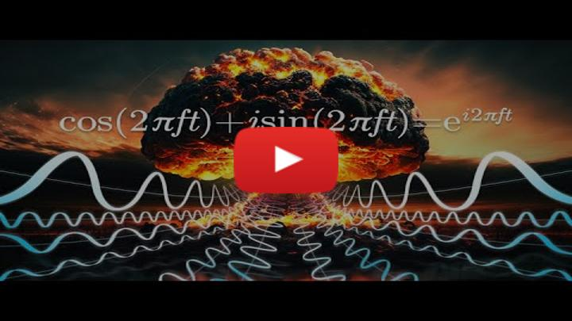
- Non-Commercial Link: https://inv.tux.pizza/watch?v=nmgFG7PUHfo
- Commercial Link: https://youtube.com/watch?v=nmgFG7PUHfo

The Discrete Fourier Transform
The foundation of this algorithm is the Discrete Fourier Transform. This is a mathematical operation that takes a discrete signal and transforms it into a continuous function of frequency. The equation for this is:
We start with complex form of the approximation of the Fourier Series:
$$f(t)=\sum_{n=−∞}^{∞}{c_{n}}e^{inω_{0}t}$$
Where $c_{n}$ is the complex coefficient of the $n$th harmonic, and $ω_{0}$ is the fundamental frequency. As we have seen before, we can rewrite this as:
$$c_{n}=\frac{1}{T_{0}}\int_{0}^{0+T_{0}}{f}(t)e^{−inω_{0}t}dt$$
Where $T_{0}$ is the period of the signal. Sometimes that integral is analytical and sometimes it isn’t. If it’s real data, it is definitely questionable if it’s analytical. So, we can approximate this integral using the trapezoidal rule:
$$c_{n}≈\frac{1}{T_{0}}\sum_{k=0}^{N−1}{f}(t_{k})e^{−inω_{0}t_{k}}Δt$$
Where $N$ is the number of samples, $t_{k}$ is the time of the $k$th sample, and $Δt$ is the time between samples. We then use this to compute the approximate signal:
$$f(t)≈\sum_{n=−∞}^{∞}{\left(\frac{1}{T_{0}}\sum_{k=0}^{N−1}{f}(t_{k})e^{−inω_{0}t_{k}}Δt\right)}e^{inω_{0}t}$$
It’s great that the numerical technique is well known and canned tools are available like scipy.integrate.trapz, but here we will start to use scipy.fft to do the heavy lifting for us.

Additional Resources
We do not expect you to understand the details of an FFT, how it is derived and how it works when written into a computer program. However, if you are interested, here are some resources that you can use to learn more about the FFT.

Videos
This is an excellent discussion of the underlying mathematics and the setup of the algorithm.
> [Image not embedded: remote images are not included in PDF export. Check the original file for the image.] 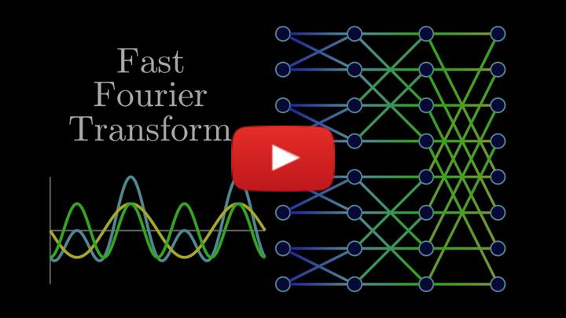
- Non-Commercial Link: https://inv.tux.pizza/watch?v=h7apO7q16V0
- Commercial Link: https://youtube.com/watch?v=h7apO7q16V0
This is a presentation of how to implement the FFT using Python code.
> [Image not embedded: remote images are not included in PDF export. Check the original file for the image.] 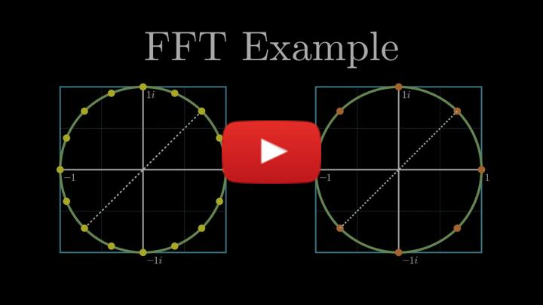
- Non-Commercial Link: https://inv.tux.pizza/watch?v=Ty0JcR6Dvis
- Commercial Link: https://youtube.com/watch?v=Ty0JcR6Dvis

Handwritten notes
- Introduction to FFT

